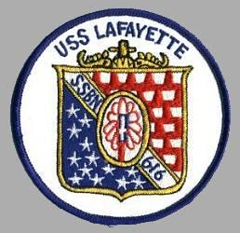 | 2022 Reunion Registration  Ashworth by the Sea Hotel  Hampton, NH  12-16 September 2022

Name:

Address:

Phone: Email:

Number of Attendees: Name(s) of Guest(s):
Registration Fee: $50 per person | $50 x = $
Association Dues (if not already paid): $20 for 2 years  (Crew Members Only) | = $
13th:  Bus to Boston Navy Yard/USS Constitution  (Admission to sites is individual responsibility) | $40 x = $
14th:  USS Albacore Tour ~$8.00 per person, individual Responsibility  Shipyard Tour - Box Lunch, Individual Responsibility | # of Box Lunches:
15th:  Closing Banquet: $50 per person | $50 x = $
TOTAL | = $
Make checks payable to: USS Lafayette Association
Mail form and checks to: Juan Castillo
1373 East Academy Avenue
Tulare, CA 93274

Must Be Received NLT 8/31/2022

